

Visit our website for great recipes and cooking tips at: www.thegood-one.com

Good-One Mfg. ~ 28100 Quick Avenue Gallatin MO 64640 ~ 660-663-8861 ~ fax 660-663-2417 ~ www.thegood-one.com

Smoker/Grill Assembly Instructions

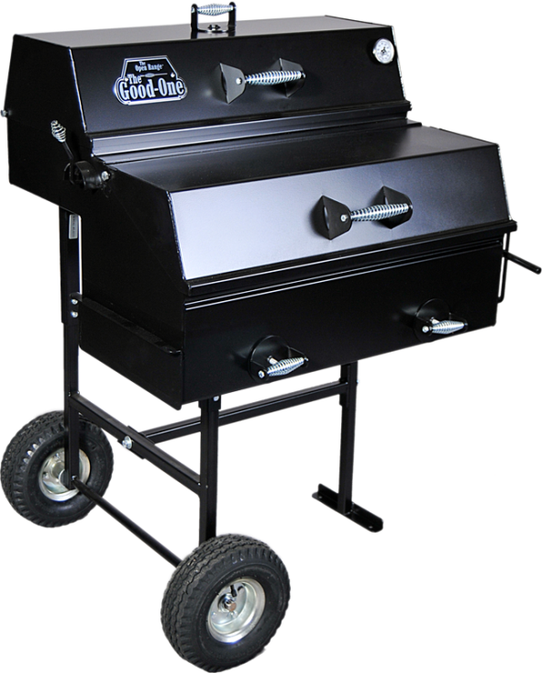

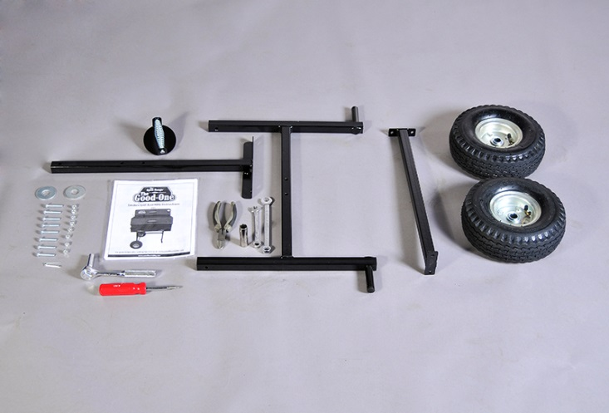

Tools Required:

Pliers or Needle Nose Pliers

Ratchet & Ratchet Extension

7/16” Socket

7/16” Wrench

9/16” Wrench

# 2 Phillips Screw Driver

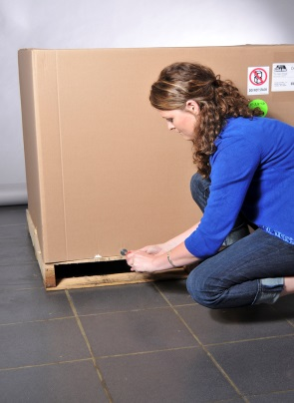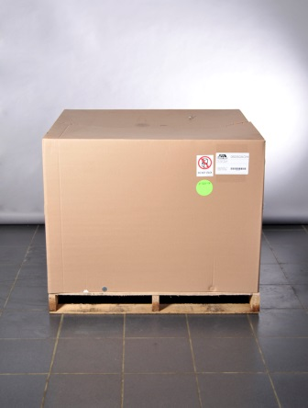

1a

1. **Preparing the Open Range™ for Assembly:**
2. Remove screws from box bottom and lift box off

the Smoker/ Grill. *Flatten box and save for further assembly.*

1. Pull protective plastic from front of Smoker/ Grill.

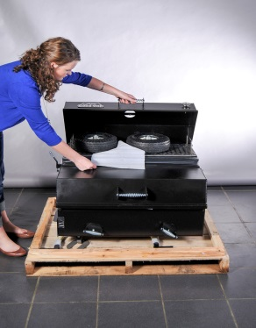Lift lids and remove all adhesive tape along edges.

1c

1b

1. 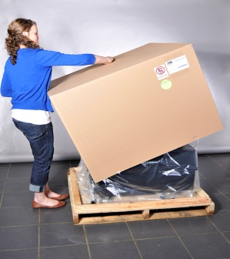Remove all parts from inside Smoker/ Grill and

under Smoker/ Grill. *Set aside for further assembly.*

1. To detach the Smoker/ Grill from the pallet, remove

¼” x 1 ½” bolts & ¼’ locknuts from three leg brackets using

a ratchet, extension, 7/16” socket, and 7/16” wrench.

*Retain these bolts for further assembly.*

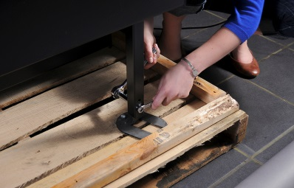

1. **Assembling Let Set:** *(requires four ¼” x ½” bolts**& ¼” locknuts)*
2. Hold Axle Leg (H- Shaped) upright with wheel axle on bottom.

Align the Leg Support, positioning each of two predrilled holes

and insert two ¼” x 1 ½” bolts with ¼” flat washers through

1d

holes from the tube side. Attach two ¼” locknuts on

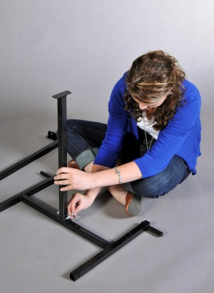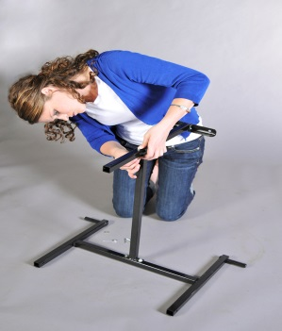the Leg Support side of the assembly.

2c-e

1. Tighten the bolts with 7/16” ratchet and 7/16” wrench.
2. Position partially assembled Leg Set to attach

the Support Leg (T-Shaped)

1. Position Leg Set to align with holes on Support Leg.

2a-b

Ensure bottom lip of Support Leg is facing away from

Axle Leg Support. Place two ¼” x 1 ½” bolts with flat

washers through holes from the tube side.

Attach two ¼” locknuts to the Leg Support side.

1. Tighten the bolts with 7/16” ratchet and 7/16” wrench.

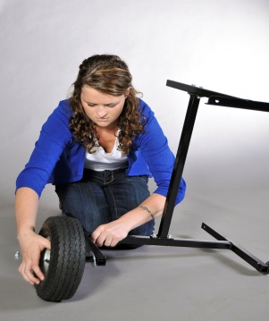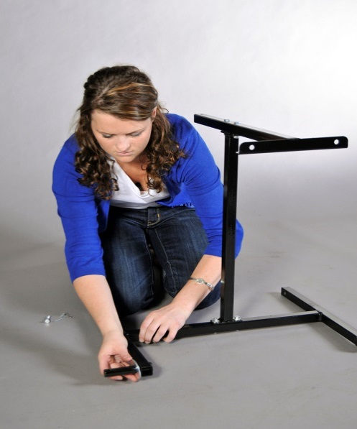**3.** **Attaching Wheels:**

*(requires two wheels, two 3/4th” flat washers, two cotter pins )*

1. Position partially assembled Leg Set on its side to position

one axle upward. Place Wheel Spacer onto axle.

3b

3a

1. 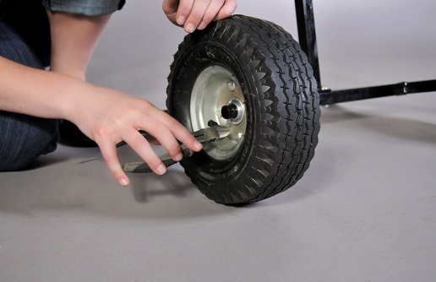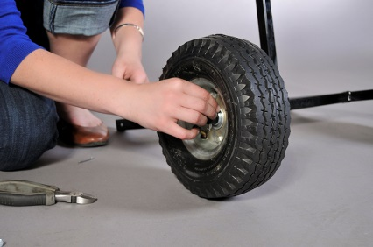Place Wheel on axle with the tire stem facing away from Leg Set.
2. Insert Cotter Pin to secure wheel
3. With pliers, bend end of cotter pin.
4. Repeat for other side

3d

3c

**4.** **Attaching Leg Set to Smoker:** *(requires four 1/4”x1 ½” bolt & locknuts.*

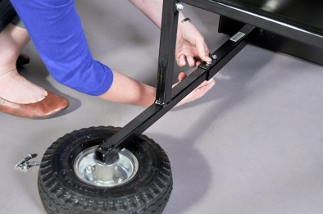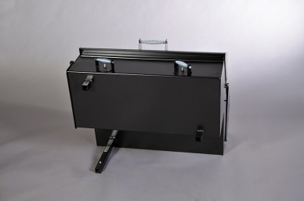*Three of these bolts were removed when removing the Smoker/Grill from*

*Pallet.)* Caution: TWO PEOPLE Recommended

1. Place the flattened box flat on the ground next to the pallet.

Place plastic over the Smoker/ Grill to protect paint finish.

4b

With a person on each side, NOT HOLDING HANDLES,

4c

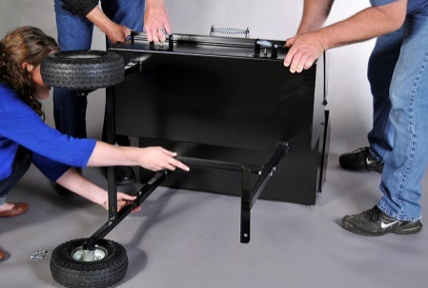slightly lift Smoker/ Grill from skid and place it on the cardboard.

1. With a person on each side, NOT HOLDING HANDLES,

lay Smoker/ Grill on back side.

1. Find the three leg brackets welded to the bottom of the

Smoker/ Grill. To prevent paint damage to the Leg Set,

insert one ¼” x 1 ½” bolt in upper hole of long leg bracket.

4d

Attach ¼” locknut and tighten.

1. Align all three legs of the Leg Set into mounting brackets.

It may be necessary to loosen the bolt in the Support Leg to insure alignment.

1. Insert three ¼” x 1 ½” bolts into predrilled holes, securing the Leg Set to the Smoker/ Grill.
2. Attach ¼’ locknuts to the ¼” x 1 ½” bolts.
3. Tighten bolts in each of three mounting locations and retighten the bolts in the Support Leg, using the 7/16” ratchet and 7/16” wrench.

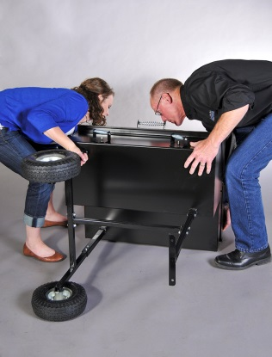**5.** **Standing the Open Range into upright position:**

*Caution: Two People Recommended*

1. With a person standing on each side of the Smoker/ Grill,

and a firm hand hold on the body of the Smoker/ Grill,

place unit in an upright position.

1. Once unit is in upright position, remove plastic and wipe away

5a

any oil or residue that may seep out with paper towel.

**6.** **Attaching the Pull Handle:** *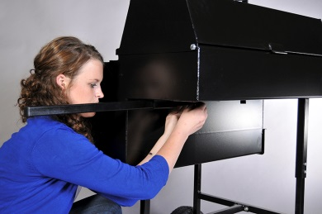(requires one ¼” x 1 ½” bolt & ¼” locknu*t)

6a-c

1. Slide Pull Handle into placement bracket located on the

back side of the grill. Position the Pull Handle so attaching

bolt can be inserted.

1. Insert ¼” x 1 ½” bolt through the end of handle and

secure with ¼’ locknut.

1. Tighten bolt with 7/16” ratchet and 7/16” wrench. Once tightened,

extend handle to insure it is securely attached to Smoker/ Grill.

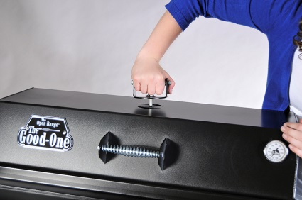

7a

**7.** **Installation of Top Air Damper:**

1. Locate pre-drilled hole on top of Smoker Box Lid. Insert Air Damper

bolt and turn clockwise direction approximately 10 turns to secure.

Air Damper will turn until it contacts top of Smoker Box Lid.

Be careful to not over tighten.

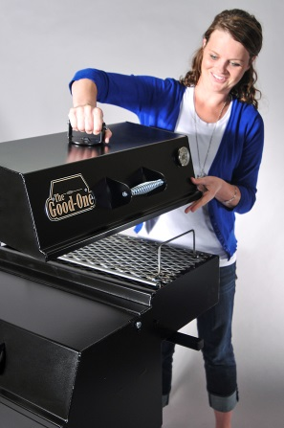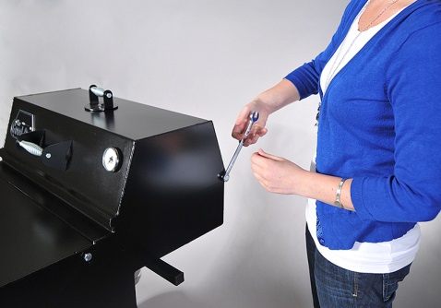**8.** ***New Feature*: Reversible Smoke Box Lid Option:**

1. To reverse Smoke Box Lid on the Open Range, using a 9/16” wrench,

remove the Hinge Bolts by turning counterclockwise. Remove the

Hinge Bolts from both sides of the Smoke Box Lid.

8b

8a

1. Lift the Smoke Box Lid from the Smoker Box and rotate 180 degrees.

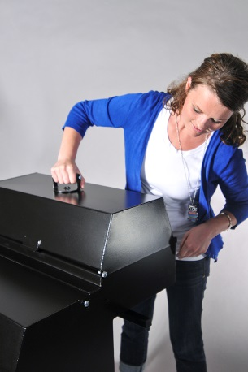Place Smoke Box Lid back on Smoker Box. Insure alignment of

Lid to Hinge Mounting Holes.

1. Replace Hinge Bolts into Hinge Mounting Holes, and turn clockwise.
2. Using 9/16” wrench, tighten Hinge Bolts. Be careful to not over tighten.

8c

**9.** ***New Feature*: Locking Firebox Lid:**

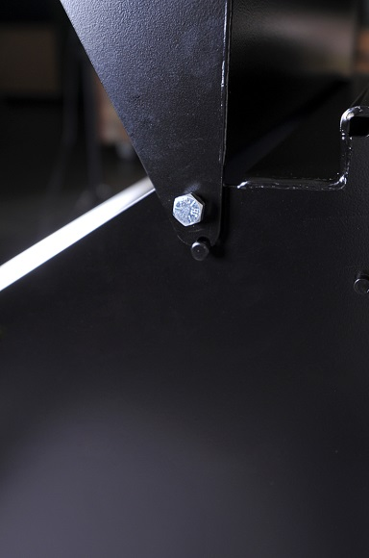

1. To remove the Ash Pan/ Charcoal Grate Assembly, lift on handles provided.
2. Lift straight up and toward the operator until clear of Smoker Body.
3. To replace, position Ash Pan/ Charcoal Grate Assembly over the Smoker Body

and slide forward while lowering the assembly into the Fire Box.

**10.** ***New Feature*: Removable Firebox lid option:**

1. Using 9/16” wrench, remove hinge bolts from both ends of Fire Box Lid.
2. Lift the Lid up and away by the Handle, setting aside and storing flat to

prevent personal injury and damage to Fire Box Lid.

1. Store the Hinge bolts in Fire Box Lid to prevent loss.

**11.** ***New Feature*: Replacing Firebox Lid Option:**

1. To replace the Fire Box Lid, Remove Hinge Bolts if necessary, and align

predrilled holes in Smoker Body and replace Hinge Bolts.

Tighten with 9/16” wrench. **Do not over tighten.**

*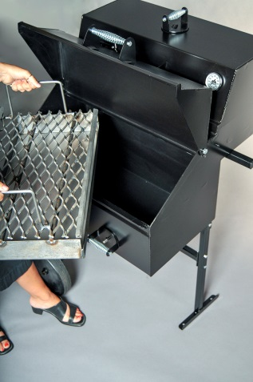***12.** ***New Feature*: Internal Ash Pan/ Charcoal Grate Assembly Option:**

1. To remove the Ash Pan/ Charcoal Grate Assembly, close the damper, lift on

handles attached to assembly.

1. Lift straight up and toward the operator until clear of Smoker Body, then pull

straight out.

1. To replace, position Ash Pan/ Charcoal Grate Assembly over the

Smoker Body and slide forward while lowering the assembly into the Fire Box.

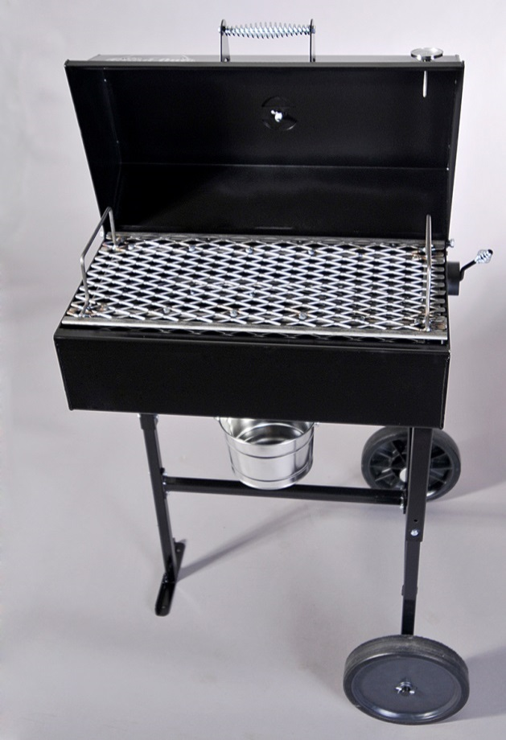

**13.** ***New Feature*: External Drip Bucket:**

1. Secure handle of Drip Bucket to external hook beneath Smoker Box.

13a

**14.** ***Upgraded Feature*: Hemmed Cooking Grates:**

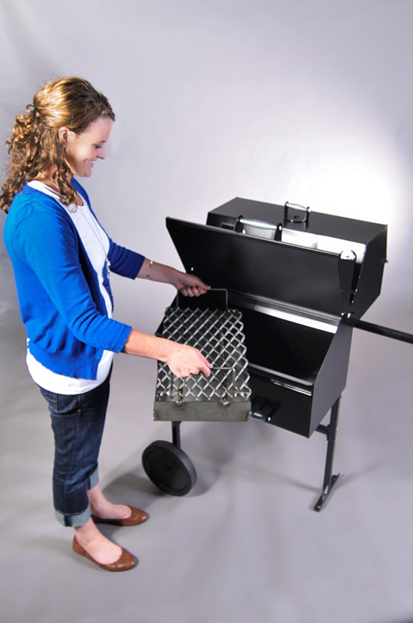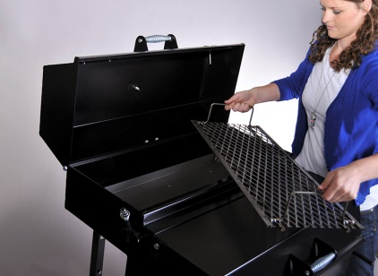

1. To locate Cooking Grates for smoking, lift Grates by handles provided,

and position in Smoker Box on brackets provided. The second grate is

positioned on handles of the first Grate.

1. To locate Cooking Grate for Grilling, lift handles provided and position

on brackets provided in Fire Box.